

Department of Mechanical Engineering

**MECH 341**

Report #5

**Fatigue testing of a notched aluminum round bar**

Section: 2

Due: 22.3.2006

Instructor:

**1/ Objective:**

A metal subjected to a repetitive stress will fail at a stress much lower than that required to cause fracture on a single application of load.

Failures occurring under conditions of dynamic loading are called fatigue failures, because they occur only after a significant period of time.

The main objective of this experiment is to measure the fatigue life that an aluminum notched bar will withstand before fatigue failure.We will further derive from this value many properties of the given specimen. The test also

reveals the effect of notching the specimen on the fatigue life.

**2/ Problem approach**

Test specimens are round bar stock made from Aluminum alloy with a diameter of 9.5mm (as seen below).

*Note*: A notch round radius (1mm) was introduced into the bar.

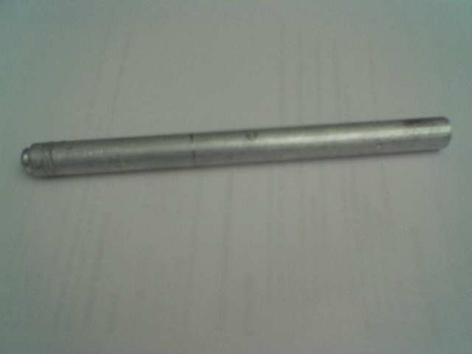

We shall measure the fatigue life of the specimen using an AUB-built fatigue testing machine (see below) which was designed to load bars in bending at mid span.



The experiment procedure can be described by the following steps:

1. The test specimen is placed in its appropriate position on the fatigue tester.
2. The motor rotates the specimen at a constant rotational speed (2800 RPM) until failure.
3. The time (number of cycles) to failure is recorded**.**

**3/ Analysis and calculations:**

**Given:**  - The weight of the load: 30 (kg) * 9.81 = 294.3 N

* The diameter of the bar: D = 9.8 mm
* The radius of the notch: r = 1mm
* The diameter of the notched part: d = 9.8 – 2 = 7.8 mm

We will derive from these given values the following properties:

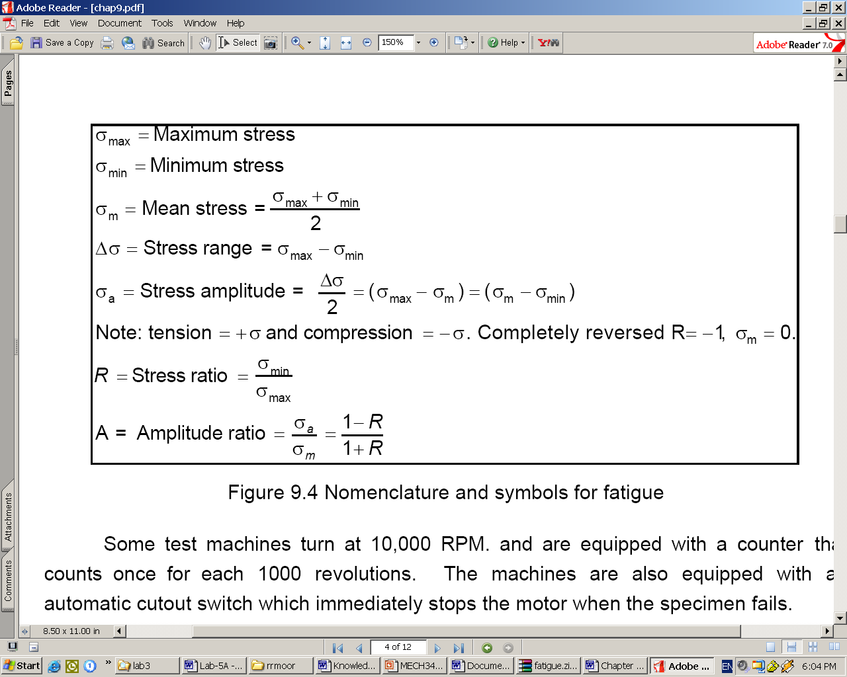

Maximum stress is given by:

**σmax = (Mc) / I**

where:

-M is the moment in the material at the section of the applied load.

M = F*s/4 ; F = 294.3 N ; s = 11.7 cm ;

M = 8.61 N.m

-c is distance from the neutral axis.

c = d / 2 = 3.9 mm = 3.9*10-3 m(for the notched part)

*-*Iis the moment of inertia section considered.

I = d4 * π / 64 = 1.8 * 10-10 m4

* σmax = (8.61 * 3.9*10-3)/ (1.8 * 10-10)

**σmax = 186550000 Pa** (tension)

* Similarly, we compute σmin:

**σmin = - 186550000 Pa** (compression)

*Note:* lσmaxl = lσminl because the neutral axis is located at the center of the

cross-section.

* **σm = 0**
* Δσ= 186550000 – (-186550000)

**Δσ = 373.1 MPa**

* σA = Δσ / 2 = 373100000 / 2

**σA = 186550000 Pa**

* R = σmin / σmax

**R = -1**

* **A is undefined.**

*A graph showing the variation of the stress the outer surface of the test specimen experiences during one rotation cycle at the notched part of the bar is given below:*

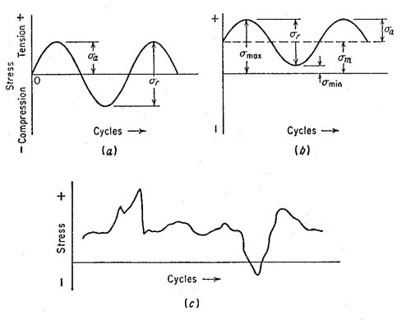

**Calculating the fatigue stress concentration factor:**

* We need to compute the fatigue stress concentration factor which is defined by the following formula:

**Kf = σmax (notched specimen) / σmax (notch-free specimen)**

Where:

σmax (notched specimen) = 186550000 Pa

and

σmax (notch-free specimen) = (Mc) / I

( c = D/2 = 9.8/2 = 4.9 mm and I = D4 * π / 64 = 4.5*10-10)

σmax (notch-free specimen) = 93753333 Pa

Kf = 186550000 / 93753333

* + **Kf = 1.9898**
* However, the fatigue stress concentration factor can be found theoretically using the following formula:

**Kf = 1+ (Kt -1)q**

Where: Kt is the theoretical or geometric factor

q is the notch sensitivity factor

These values can be determined with the help of the following graphs:

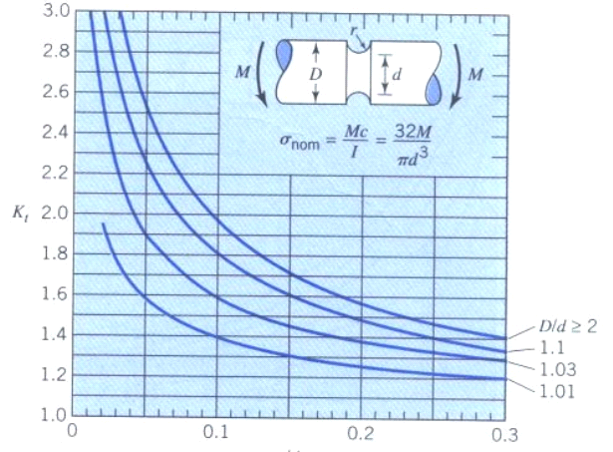

**r/d**

r/d = 1 / 7.8 ≈ 0.13 and D/d = 9.8 / 7.8 ≈ 1.2

**=>** **Kt = 1.7**

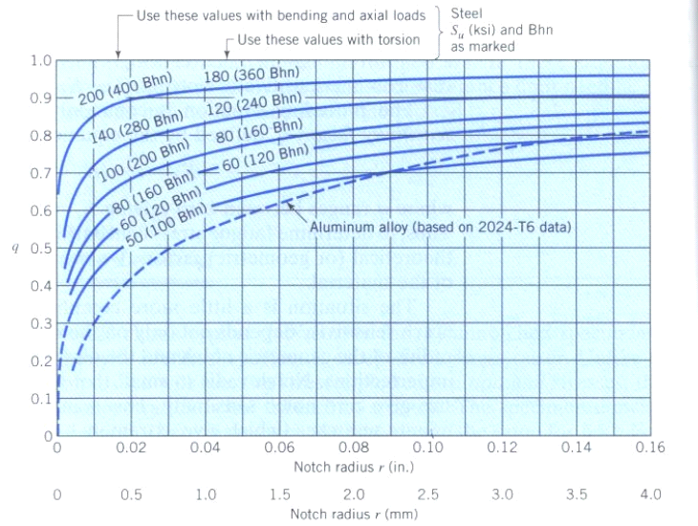

Notch radius = 1mm

**=> q = 0.54**

Hence, Kf = 1+ (Kt -1)q = 1 + (1.7 – 1)*0.54

**Kf = 1.38**

The relative error between the measured factor and the theoretical one is:

[Kf (measured) – Kf (theoretical)] / Kf (theoretical) * 100 ≈ 43 %

